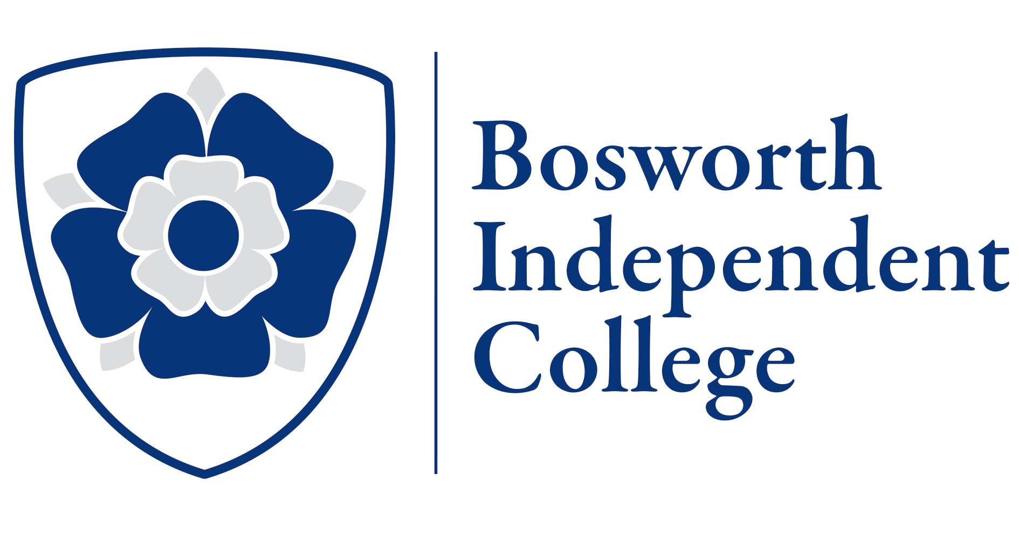

Bursary Form
Please complete the form if you would like to apply for a bursary. Once completed submit the finished form and income details (previous 3 months’ pay slips and most recent P60) to info@bosworthcollege.com

Student’s name

Date of birth
Course applied for
Qualifications achieved so far (with grades where applicable)

Mother’s name
Father’s name
Home address
Contact details:
Name
E-mail
Phone number
Mother’s occupation
Yearly income before tax
Father’s occupation
Yearly income before tax

To be completed by the College
Proof of income | Yes/No
Any other relevant information

Bursary Agreed | Yes/No
Bursary Percentage
Agreed by
Signature
Date

